Assignment no .12
Hashing

Course Name : Data Structures-I
Course Code : CS2301
Div : SEDA-B
Student Name : Yashraj Dinesh Hande
Roll Number : 18
Date of Submission : 28/11/2025

Problem 1: WAP to simulate a faculty database as a hash table. Search a particular faculty by using 'divide' as a hash function for linear probing with chaining without replacement method of collision handling technique. Assume suitable data for faculty record.

CODE:
#include <iostream>
#include <list> // For linked list
using namespace std;

class HashTable {
private:
int size; // number of buckets
list<int> *table; // array of linked lists

public:
// Constructor
HashTable(int s) {
size = s;
table = new list<int>[size];
}

// Hash function
int hashFunction(int key) {
return key % size;
}

// Insert key
void insert(int key) {
int index = hashFunction(key);
table[index].push_back(key);
cout << "Inserted key " << key << " at index " << index << endl;
}

// Search key
void search(int key) {
int index = hashFunction(key);
for (auto it = table[index].begin(); it != table[index].end(); ++it) {
if (*it == key) {
cout << "Key " << key << " found at index " << index << endl;
return;
}
}
cout << "Key " << key << " not found!" << endl;
}

// Delete key
void remove(int key) {
int index = hashFunction(key);
auto it = table[index].begin();
while (it != table[index].end()) {
if (*it == key) {
it = table[index].erase(it);
cout << "Key " << key << " deleted from index " << index << endl;
return;
} else {
++it;
}
}
cout << "Key " << key << " not found for deletion!" << endl;
}

// Display table
void display() {
cout << "\nHash Table (Separate Chaining):\n";
for (int i = 0; i < size; i++) {
cout << "Index " << i << ": ";
if (table[i].empty()) {
cout << "EMPTY";
} else {
for (auto x : table[i]) {
cout << x << " -> ";
}
cout << "NULL";
}
cout << endl;
}
}
};

int main() {
int size;
cout << "Enter hash table size: ";
cin >> size;
HashTable ht(size);
int choice, key;
do {
cout << "\n--- Hash Table (Separate Chaining) ---";
cout << "\n1. Insert Key";
cout << "\n2. Search Key";
cout << "\n3. Delete Key";
cout << "\n4. Display Table";
cout << "\n5. Exit";
cout << "\nEnter your choice: ";
cin >> choice;

switch (choice) {
case 1:
cout << "Enter key to insert: ";
cin >> key;
ht.insert(key);
break;
case 2:
cout << "Enter key to search: ";
cin >> key;
ht.search(key);
break;
case 3:
cout << "Enter key to delete: ";
cin >> key;
ht.remove(key);
break;
case 4:
ht.display();
break;
case 5:
cout << "Exiting...\n";
break;
default:
cout << "Invalid choice!\n";
}
} while (choice != 5);

return 0;
}

OUTPUT:
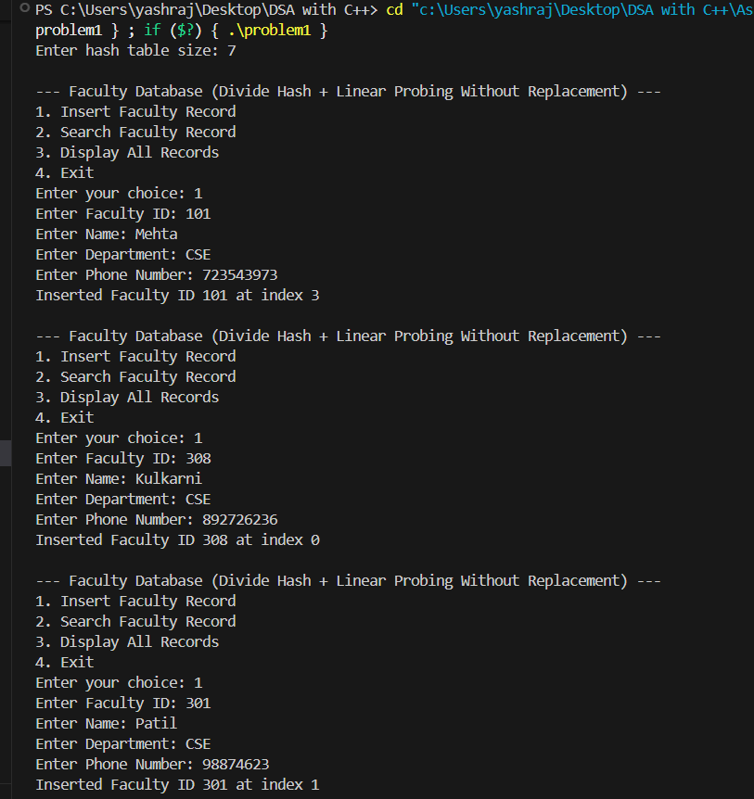
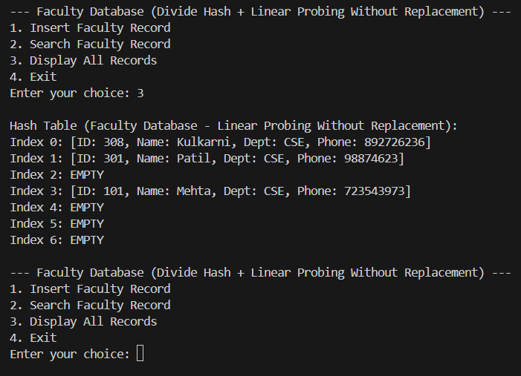
Problem 2: WAP to simulate a faculty database as a hash table. Search a particular faculty by using MOD as a hash function for linear probing with chaining with replacement method of collision handling technique. Assume suitable data for faculty record.

CODE:
#include <iostream>
#include <list> // For linked list
using namespace std;

class HashTable {
private:
int size; // number of buckets
list<int> *table; // array of linked lists

public:
// Constructor
HashTable(int s) {
size = s;
table = new list<int>[size];
}

// Hash function
int hashFunction(int key) {
return key % size;
}

// Insert key
void insert(int key) {
int index = hashFunction(key);
table[index].push_back(key);
cout << "Inserted key " << key << " at index " << index << endl;
}

// Search key
void search(int key) {
int index = hashFunction(key);
for (auto it = table[index].begin(); it != table[index].end(); ++it) {
if (*it == key) {
cout << "Key " << key << " found at index " << index << endl;
return;
}
}
cout << "Key " << key << " not found!" << endl;
}

// Delete key
void remove(int key) {
int index = hashFunction(key);
auto it = table[index].begin();
while (it != table[index].end()) {
if (*it == key) {
it = table[index].erase(it);
cout << "Key " << key << " deleted from index " << index << endl;
return;
} else {
++it;
}
}
cout << "Key " << key << " not found for deletion!" << endl;
}

// Display table
void display() {
cout << "\nHash Table (Separate Chaining):\n";
for (int i = 0; i < size; i++) {
cout << "Index " << i << ": ";
if (table[i].empty()) {
cout << "EMPTY";
} else {
for (auto x : table[i]) {
cout << x << " -> ";
}
cout << "NULL";
}
cout << endl;
}
}
};

int main() {
int size;
cout << "Enter hash table size: ";
cin >> size;

HashTable ht(size);

int choice, key;
do {
cout << "\n--- Hash Table (Separate Chaining) ---";
cout << "\n1. Insert Key";
cout << "\n2. Search Key";
cout << "\n3. Delete Key";
cout << "\n4. Display Table";
cout << "\n5. Exit";
cout << "\nEnter your choice: ";
cin >> choice;

switch (choice) {
case 1:
cout << "Enter key to insert: ";
cin >> key;
ht.insert(key);
break;
case 2:
cout << "Enter key to search: ";
cin >> key;
ht.search(key);
break;
case 3:
cout << "Enter key to delete: ";
cin >> key;
ht.remove(key);
break;
case 4:
ht.display();
break;
case 5:
cout << "Exiting...\n";
break;
default:
cout << "Invalid choice!\n";
}
} while (choice != 5);

return 0;
}

OUTPUT:
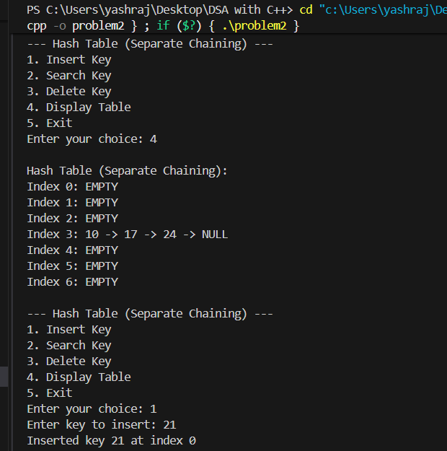
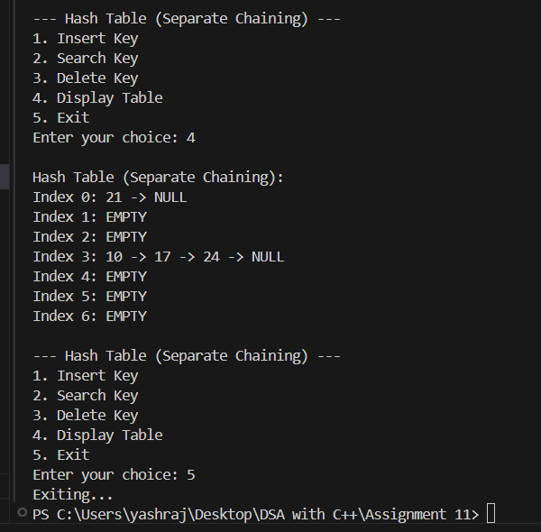

Problem 3 : Implement collision resolution using linked lists.

CODE:
#include <iostream>
using namespace std;

// Node structure for linked list
struct Node {
int data;
Node* next;
};

// HashTable class using Linked Lists for collision resolution
class HashTable {
private:
Node** table; // Array of pointers (each points to a linked list)
int size;

// Hash function
int hashFunction(int key) {
return key % size;
}

public:
// Constructor
HashTable(int s) {
size = s;
table = new Node*[size];
for (int i = 0; i < size; i++) {
table[i] = nullptr;
}
}

// Insert key into hash table
void insert(int key) {
int index = hashFunction(key);
Node* newNode = new Node{key, nullptr};

// If no linked list exists at this index
if (table[index] == nullptr) {
table[index] = newNode;
} else {
// Append to existing linked list (end)
Node* temp = table[index];
while (temp->next != nullptr)
temp = temp->next;
temp->next = newNode;
}

cout << "Inserted key " << key << " at index " << index << endl;
}

// Search key in hash table
void search(int key) {
int index = hashFunction(key);
Node* temp = table[index];
while (temp != nullptr) {
if (temp->data == key) {
cout << "Key " << key << " found at index " << index << endl;
return;
}
temp = temp->next;
}
cout << "Key " << key << " not found!" << endl;
}

// Delete key from hash table
void remove(int key) {
int index = hashFunction(key);
Node* temp = table[index];
Node* prev = nullptr;

while (temp != nullptr && temp->data != key) {
prev = temp;
temp = temp->next;
}

if (temp == nullptr) {
cout << "Key " << key << " not found for deletion!" << endl;
return;
}

if (prev == nullptr) {
// Delete head node
table[index] = temp->next;
} else {
// Bypass node
prev->next = temp->next;
}

delete temp;
cout << "Key " << key << " deleted from index " << index << endl;
}

// Display entire hash table
void display() {
cout << "\nHash Table (Collision Resolution using Linked Lists):\n";
for (int i = 0; i < size; i++) {
cout << "Index " << i << ": ";
Node* temp = table[i];
if (temp == nullptr) {
cout << "EMPTY";
} else {
while (temp != nullptr) {
cout << temp->data << " -> ";
temp = temp->next;
}
cout << "NULL";
}
cout << endl;
}
}
};

// ---------- main() ----------
int main() {
int size;
cout << "Enter hash table size: ";
cin >> size;

HashTable ht(size);
int choice, key;

do {
cout << "\n--- Hash Table (Linked List Collision Handling) ---";
cout << "\n1. Insert Key";
cout << "\n2. Search Key";
cout << "\n3. Delete Key";
cout << "\n4. Display Table";
cout << "\n5. Exit";
cout << "\nEnter choice: ";
cin >> choice;

switch (choice) {
case 1:
cout << "Enter key to insert: ";
cin >> key;
ht.insert(key);
break;

case 2:
cout << "Enter key to search: ";
cin >> key;
ht.search(key);
break;

case 3:
cout << "Enter key to delete: ";
cin >> key;
ht.remove(key);
break;

case 4:
ht.display();
break;

case 5:
cout << "Exiting...\n";
break;

default:
cout << "Invalid choice!\n";
}

} while (choice != 5);

return 0;
}

OUTPUT:
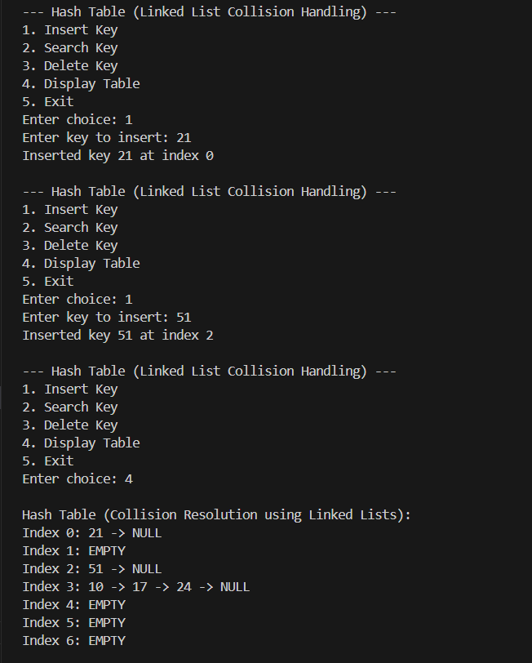

Problem 4 : Write a Program to implement Dijkstra’s algorithm to find shortest distance between two nodes of a user defined graph. Use Adjacency List to represent a graph.

CODE:
// Store and retrieve student records using roll numbers.

#include <iostream>
#include <string>
using namespace std;

// Structure to store student details
struct Student {
int roll;
string name;
string dept;
float marks;
Student* next;
};

// Hash Table Class
class HashTable {
private:
Student** table; // array of linked lists
int size;

// Hash function (using roll number)
int hashFunction(int roll) {
return roll % size;
}

public:
// Constructor
HashTable(int s) {
size = s;
table = new Student*[size];
for (int i = 0; i < size; i++)
table[i] = nullptr;
}

// Insert student record
void insertStudent(int roll, string name, string dept, float marks) {
int index = hashFunction(roll);
Student* newStudent = new Student{roll, name, dept, marks, nullptr};

if (table[index] == nullptr) {
table[index] = newStudent;
} else {
// Collision → add to linked list (end)
Student* temp = table[index];
while (temp->next != nullptr)
temp = temp->next;
temp->next = newStudent;
}

cout << "Record inserted for Roll No: " << roll << " at index " << index << endl;
}

// Search student record by roll number
void searchStudent(int roll) {
int index = hashFunction(roll);
Student* temp = table[index];

while (temp != nullptr) {
if (temp->roll == roll) {
cout << "\nRecord Found:\n";
cout << "Roll No: " << temp->roll << endl;
cout << "Name: " << temp->name << endl;
cout << "Department: " << temp->dept << endl;
cout << "Marks: " << temp->marks << endl;
return;
}
temp = temp->next;
}

cout << "\nRecord not found for Roll No: " << roll << endl;
}

// Display all records
void displayAll() {
cout << "\nHash Table (Student Records):\n";
for (int i = 0; i < size; i++) {
cout << "Index " << i << ": ";
Student* temp = table[i];

if (temp == nullptr) {
cout << "EMPTY";
} else {
while (temp != nullptr) {
cout << "[Roll: " << temp->roll << ", Name: " << temp->name
<< ", Dept: " << temp->dept << ", Marks: " << temp->marks << "] -> ";
temp = temp->next;
}
cout << "NULL";
}
cout << endl;
}
}

// Delete a record
void deleteStudent(int roll) {
int index = hashFunction(roll);
Student* temp = table[index];
Student* prev = nullptr;

while (temp != nullptr && temp->roll != roll) {
prev = temp;
temp = temp->next;
}

if (temp == nullptr) {
cout << "Record not found for deletion!" << endl;
return;
}

if (prev == nullptr) {
table[index] = temp->next; // delete head
} else {
prev->next = temp->next;
}

delete temp;
cout << "Record deleted for Roll No: " << roll << endl;
}
};

// ---------- main() ----------
int main() {
int size;
cout << "Enter hash table size: ";
cin >> size;

HashTable ht(size);
int choice, roll;
string name, dept;
float marks;

do {
cout << "\n--- Student Record Hash Table ---";
cout << "\n1. Insert Student Record";
cout << "\n2. Search Student Record";
cout << "\n3. Delete Student Record";
cout << "\n4. Display All Records";
cout << "\n5. Exit";
cout << "\nEnter your choice: ";
cin >> choice;

switch (choice) {
case 1:
cout << "Enter Roll No: ";
cin >> roll;
cout << "Enter Name: ";
cin >> name;
cout << "Enter Department: ";
cin >> dept;
cout << "Enter Marks: ";
cin >> marks;
ht.insertStudent(roll, name, dept, marks);
break;

case 2:
cout << "Enter Roll No to search: ";
cin >> roll;
ht.searchStudent(roll);
break;

case 3:
cout << "Enter Roll No to delete: ";
cin >> roll;
ht.deleteStudent(roll);
break;

case 4:
ht.displayAll();
break;
case 5:
cout << "Exiting...\n";
break;
default:
cout << "Invalid choice!\n";
}
} while (choice != 5);

return 0;
}
OUTPUT:
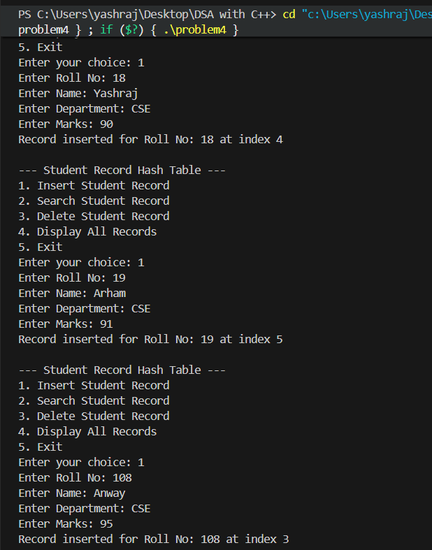
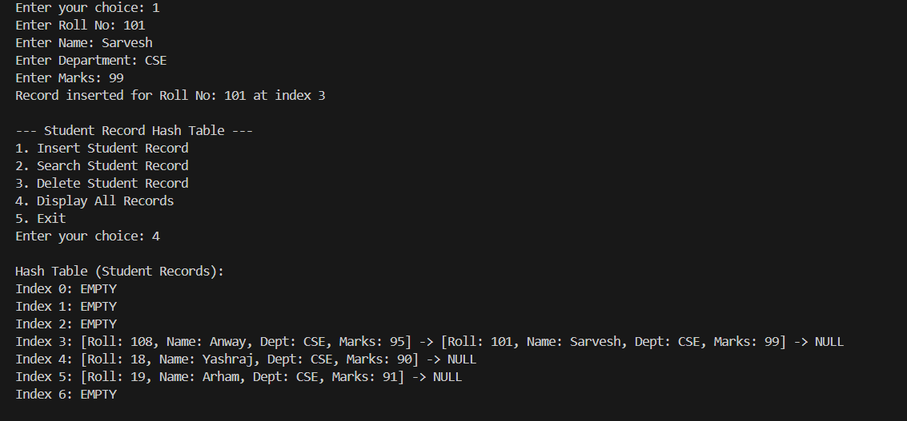

Problem 5 : WAP to simulate a faculty database as a hash table. Search a particular faculty by using MOD as a hash function for linear probing method of collision handling technique. Assume suitable data for faculty record.
CODE:
// WAP to simulate a faculty database as a hash table.
// Search a particular faculty by using MOD as a hash function for linear
// probing method of collision handling technique. Assume suitable data for faculty record.

#include <iostream>
#include <string>
using namespace std;

// Structure to store faculty details
struct Faculty {
int id;
string name;
string dept;
string phone;
};

// Hash table class using MOD + Linear Probing
class HashTable {
private:
Faculty* table;
bool* occupied; // To track used slots
int size;

// Hash function using MOD method
int hashFunction(int key) {
return key % size;
}

public:
// Constructor
HashTable(int s) {
size = s;
table = new Faculty[size];
occupied = new bool[size];
for (int i = 0; i < size; i++)
occupied[i] = false;
}

// Insert faculty record
void insertFaculty(int id, string name, string dept, string phone) {
int index = hashFunction(id);
int startIndex = index;

// Linear probing
while (occupied[index]) {
index = (index + 1) % size;
if (index == startIndex) {
cout << "Hash Table is full! Cannot insert record for ID " << id << endl;
return;
}
}

table[index].id = id;
table[index].name = name;
table[index].dept = dept;
table[index].phone = phone;
occupied[index] = true;

cout << "Inserted record for Faculty ID " << id << " at index " << index << endl;
}

// Search faculty by ID
void searchFaculty(int id) {
int index = hashFunction(id);
int startIndex = index;

while (occupied[index]) {
if (table[index].id == id) {
cout << "\nFaculty Found at index " << index << ":\n";
cout << "Faculty ID : " << table[index].id << endl;
cout << "Name : " << table[index].name << endl;
cout << "Department : " << table[index].dept << endl;
cout << "Phone No. : " << table[index].phone << endl;
return;
}

index = (index + 1) % size;
if (index == startIndex) break; // full loop
}

cout << "\nFaculty with ID " << id << " not found!" << endl;
}

// Display all faculty records
void displayTable() {
cout << "\nHash Table (Faculty Database):\n";
for (int i = 0; i < size; i++) {
cout << "Index " << i << ": ";
if (occupied[i]) {
cout << "[ID: " << table[i].id
<< ", Name: " << table[i].name
<< ", Dept: " << table[i].dept
<< ", Phone: " << table[i].phone << "]";
} else {
cout << "EMPTY";
}
cout << endl;
}
}
};

// ---------- main() ----------
int main() {
int size;
cout << "Enter hash table size: ";
cin >> size;

HashTable ht(size);

int choice, id;
string name, dept, phone;

do {
cout << "\n--- Faculty Database (Linear Probing with MOD Hash) ---";
cout << "\n1. Insert Faculty Record";
cout << "\n2. Search Faculty Record";
cout << "\n3. Display All Records";
cout << "\n4. Exit";
cout << "\nEnter your choice: ";
cin >> choice;

switch (choice) {
case 1:
cout << "Enter Faculty ID: ";
cin >> id;
cout << "Enter Name: ";
cin >> name;
cout << "Enter Department: ";
cin >> dept;
cout << "Enter Phone Number: ";
cin >> phone;
ht.insertFaculty(id, name, dept, phone);
break;

case 2:
cout << "Enter Faculty ID to search: ";
cin >> id;
ht.searchFaculty(id);
break;

case 3:
ht.displayTable();
break;

case 4:
cout << "Exiting...\n";
break;

default:
cout << "Invalid choice!\n";
}

} while (choice != 4);

return 0;
}

OUTPUT:
